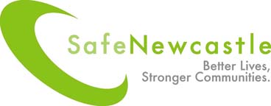

Domestic Violence and Abuse
Multi-Agency Training Programme

May 2019 – March 2020

Contents: | Page:
Introduction | 2
Charges, training booking terms and conditions | 4
Guidance notes to help you register for training | 5
Further training available in Newcastle | 11
Courses:
Domestic Violence and Abuse Awareness Raising (Level 1)  *** CPD accredited training from September 2018 *** | 6-7
Domestic Violence and Abuse Ask and Act Training (Level 2)  *** CPD accredited training from May 2019 *** | 8-9
Domestic Violence and Abuse Trusted Professional Training (Level 3)  *** CPD accredited training from autumn 2019 *** | 10

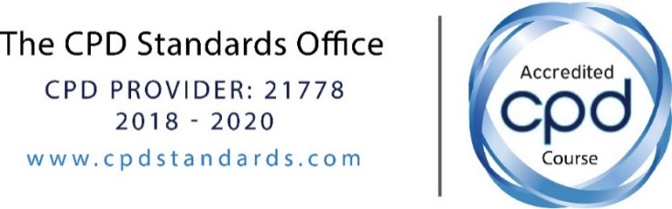

Introduction

Safe Newcastle is pleased to introduce its Domestic Violence and Abuse Multi-Agency Training Programme for 2019 – 2020.

Safe Newcastle training can help you recognise the signs, symptoms and indicators of domestic violence and abuse, understand the issues affecting victims and their families and respond quickly and effectively when someone needs protection, help and support.

Who are the courses for?

The training programme is primarily aimed at managers, paid staff and volunteers who may come into contact with victims of domestic violence and abuse, perpetrators of abuse and / or children living in families where domestic violence and abuse is occurring.

The training courses are suitable for staff from many different sectors and organisations, including, but not limited to:

- Specialist domestic and sexual violence service providers
- Health professionals, for example, midwives, health visitors, GPs, nurses, mental health services
- Adult and children’s social care practitioners
- Children’s Centres and voluntary sector children’s organisations
- Education sector
- Housing and hostel services
- Alcohol and drug services
- Criminal justice agencies

Please read the outline for each course you are interested in attending to ensure the course aim and learning objectives are relevant to your role. If you would like to discuss your training requirements prior to booking, please contact:

Joanne Douglas
Workforce Development and Training Officer (Violence against Women and Girls)
0191 211 5872 / 07881 686 568
joanne.douglas@newcastle.gov.uk

About the training
All of the courses listed in this programme are delivered in a multi-agency setting. This provides participants with the opportunity to share their experience, skills and knowledge and learn about other agencies’ roles, responsibilities and limitations in relation to the topics covered.

Please note: due to the multi-agency nature of these courses, we can only accept a maximum of three people from the same organisation on each session. If you would like to train a larger group of staff in one session, please contact Joanne Douglas to discuss cost and requirements.

All of the courses are delivered using various training methods including small group work, DVDs, PowerPoint presentation, trainer led inputs, skills practice and case studies. The training is highly interactive and based upon current best practice and evidence of what works well in response to domestic violence and abuse.

Content warning
Please be aware that this training programme deals with potentially emotive subjects. The content and materials used may be upsetting to anyone who has been personally affected by domestic violence and abuse. Information is provided about help lines and local and national support agencies that can be contacted should you feel the need to talk to someone other than your colleagues or manager following attendance on a course.

Single agency training
In addition to these multi-agency training events, Safe Newcastle can provide tailored training to meet your organisation’s specific requirements. There may be a charge for this. For further details of ‘in house’ training opportunities or to discuss your organisation’s requirements and receive a quote please contact Joanne Douglas.

Equal Opportunities
Safe Newcastle is committed to a policy of Equal Opportunities and of valuing and respecting difference and diversity. We aim to provide access to training regardless of a person’s ethnicity, disability, sexual orientation, gender identity, age or religion.

We aim to ensure that all our courses are inclusive and avoid discrimination in all respects. This is an integral objective in our planning and preparation of the training and at all times we undertake to:
~ Ensure that all participants are treated as individuals
~ Respect the opinion and experience of others
~ Appropriately challenge discriminating language or any oppressive behaviour

If you would like to discuss any specific access requirements prior to booking on a course, or provide feedback relating to this following attendance on a course, please contact Joanne Douglas.

Charges, training booking terms and conditions

Charges for attendance

Training is free to most organisations operating within Newcastle upon Tyne. Profit-making organisations and organisations operating outside of Newcastle are welcome to attend but will be expected to pay a fee of £40 per person per day.

Drinks are provided on the courses but we are unable to provide lunch.

Cancellations and non-attendance fees

If you are booked to attend a course but are subsequently unable to attend or you are unable to attend for the entire course, you must cancel your booking on Eventbrite as soon as you become aware of this so that the place will be available for someone else.

Cancellations must be received within 5 working days of the course start date, although they will be accepted after this for those who are ill or have other extenuating circumstances, which have been approved by their line manager.

The booking organisation will pay the full late cancellation fee of £40 for anyone who does not attend and did not cancel their place or fails to stay for the entire duration of the course.

You must attend the entire course and complete the SurveyMonkey post-course follow-up questionnaire to receive your CPD attendance certificate and learning tool.

Safe Newcastle reserves the right to cancel courses. If this happens we will inform you as soon as we possibly can and will offer an alternative date where possible.

Our Data Protection Policy can be viewed here

Guidance notes to help you register for training

Registration and allocation of places

All bookings are managed via the Eventbrite website. Click on the ‘Register here’ hyperlink next to the course you would like to attend and complete the online registration form.

If the link doesn’t work on your PC, try right clicking on the hyperlink, then click on ‘open hyperlink’ or copy and paste the link in to your internet browser adding the ‘www’ prefix if necessary. If you still experience a problem, please contact your IT department for advice as all bookings must be completed via the Eventbrite website.

Unfortunately, we can’t accept applications for training unless your line manager agrees to the booking terms and conditions and has given authorisation for you to attend. Your line manager’s contact details must be included on the registration form. By providing these details you are confirming that your manager has authorised your attendance.

Once you have completed the online registration process you will receive an e-mail confirmation from Eventbrite. You will also receive a further e-mail confirmation from Safe Newcastle three weeks prior to the course date. You are advised to make a note of the date of the course you have applied for in your calendar and / or diary to ensure you are available to attend the course.

For further information about any of the courses offered in this programme, please contact:

Joanne Douglas
Workforce Development and Training Officer (Violence against Women and Girls)
0191 211 5872 / 07881 686 568
joanne.douglas@newcastle.gov.uk

Domestic Violence and Abuse Awareness Raising (Level 1)

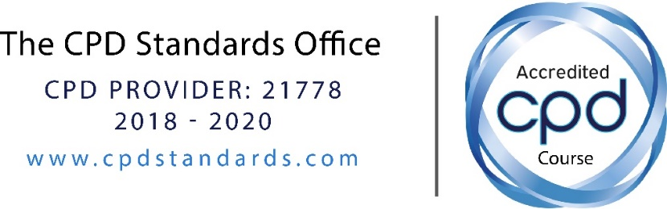

What is the aim of this course?

To raise participants’ knowledge and understanding of the nature and impact of domestic violence and abuse.

What will the course cover?

By the end of the course, the learner will:

1. Know the Government definition of domestic violence and abuse
2. Explore the different types of abusive behaviours used by perpetrators of domestic violence and abuse
3. Comprehend the impact of domestic violence and abuse on victims and survivors
4. Know the prevalence of domestic violence and abuse
5. Recognise the myths relating to the causes of domestic violence and abuse
6. Explore how discrimination in society contributes to the experience and impact of domestic violence and abuse
7. Know the specialist support services and interventions available for victims, children and perpetrators

Who should attend?

This is a basic level awareness raising course therefore no prior knowledge is necessary. The course is suitable for anyone who may come into contact with victims of abuse, perpetrators and / or children living in families where abuse is occurring.

This course has been developed and accredited by the Office of the Police and Crime Commissioner for Northumbria and equates to 6 CPD hours / points.

Time: 9.30 am to 4.30 pm

Dates and venues:

Wednesday 1 May 2019 Molineux Street NHS Centre, Byker Register here

Thursday 27 June 2019 West End Customer Service Centre Register here

Tuesday 10 September 2019 Kenton Centre, Hillsview Avenue Register here

Thursday 3 October 2019 Molineux Street NHS Centre, Byker Register here

Thursday 7 November 2019 West End Customer Service Centre Register here

Tuesday 14 January 2020 Molineux Street NHS Centre, Byker Register here

Wednesday 5 February 2020 Kenton Centre, Hillsview Avenue Register here

Thursday 5 March 2020 West End Customer Service Centre Register here

Domestic Violence and Abuse Ask and Act Training (Level 2)

What is the aim of this course?

To enable participants to ‘Ask’ clients if they are experiencing domestic violence and abuse and to ‘Act’ so the harms caused by domestic violence and abuse are reduced.

What will the course cover?

By the end of the course, the learner will:

1. Understand what domestic violence and abuse is
2. Recognise the indicators of domestic violence and abuse
3. Understand the purpose of targeted enquiry and employ good practice when undertaking targeted enquiry
4. Respond to disclosures safely and effectively
5. Understand the purpose of risk identification, employ good practice when undertaking risk identification and follow referral pathways
6. Understand responsibilities around confidentiality and information sharing

Who should attend?

The course is suitable for anyone who may come into contact with victims of DVA and perform roles that enable them to facilitate and respond appropriately to disclosures.

To attend this course, applicants must have previously attended a level 1 DVA awareness raising training course. This could be the course provided in this programme or training received elsewhere. You will be required to give details when completing the online booking form.

Time: 9:30 am to 4:30 pm
All courses will take place at Newcastle Civic Centre
Dates:

Tuesday 21 May 2019 Register here

Wednesday 18 September 2019 Register here

Thursday 10 October 2019 Register here

Tuesday 12 November 2019 Register here

Monday 20 January 2020 Register here

Thursday 13 February 2020 Register here

Additional information:

This course has been developed and accredited by the Office of the Police and Crime Commissioner for Northumbria and equates to 6 CPD hours / points.

Domestic Violence and Abuse Trusted Professional Training (Level 3)

What is the aim of this course?

To be confirmed – the level 3 course is currently in development; it will be finalised and ready for delivery late 2019.

What will the course cover?

To be confirmed, but will include learning outcomes relating to:
- Power dynamics in the practitioner-victim working relationship and ‘system-induced risk’
- Working with victims and survivors of DVA:
  - Developing a survivor centred, needs-led approach
  - Developing a strengths-based approach and identifying / utilising protective factors
  - Trauma informed practice
  - Intersectionality
  - Expanding a survivor’s space for action
  - Stages of Change model and motivational interviewing
  - Challenging practitioner assumptions / biases relating to myths about DVA
  - Providing basic information on options for information and support
- Working with the perpetrator in mind
- Impact on children and strengthening the mother-child relationship

Who should attend?

The course will be suitable for anyone who comes into contact with victims of domestic violence and abuse, perpetrators and / or children living in families where domestic violence and abuse is occurring and who have significant, regular contact with victims and / or perpetrators and who might be expected, with training, to identify and respond to their initial support needs rather than immediately signpost or refer them to a specialist domestic violence and abuse service.

To attend this course, applicants must have previously attended a level 1 DVA awareness training course. This could be the course provided in this programme or training received elsewhere. You will be required to give details when completing the online registration form.

You must have also previously attended the level 2 Domestic Violence and Abuse Ask and Act training course in this programme. You will be required to give details when completing the online registration form.

Times, dates and venues:

To be confirmed – this will be an advanced level, modular course, 3 or 4 days in duration.

If you would like to receive further information about this course when it is available, please click here and complete the online registration form. You are not registering to attend the course at this stage – you are only registering your interest. The course organiser will contact you with further information and joining instructions when the course becomes available.

Additional information:

This course has been developed and accredited by the Office of the Police and Crime Commissioner for Northumbria and equates to xxx CPD hours / points.

Further training available in Newcastle

Please note, the training programmes listed here are not provided by Safe Newcastle. If you have any questions relating to these courses, please use the contact details provided on the relevant websites.

Newcastle Safeguarding Children Board training:
https://www.nscb.org.uk/training-courses

Training and development for the children's workforce:
http://www.newcastle.gov.uk/education-and-learning/training-and-development-for-the-childrens-workforce

Safeguarding Adults Learning and Development:
http://www.newcastle.gov.uk/social-care-and-health/safeguarding-and-abuse/safeguarding-information-professionals/safeguarding-adults-learning-and-developmen

Newcastle Sexual Health Training Directory:
http://www.newcastle.gov.uk/social-care-and-health/health-and-wellbeing/sexual-health/sexual-health-training-directory

Changing Lives GAP and MAP Project Sex Work and Sexual Exploitation training:
E-mail Laura.Mcintyre@changing-lives.org.uk

